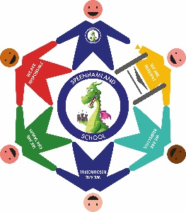

**PARENTS HANDBOOK 2021-2022**



**Welcome from the Headteacher**

Speenhamland Primary School is proud of its rich diversity and welcomes children from a range of backgrounds. High quality teaching and learning is at the heart of everything we do. We strive to provide rich learning experiences for our pupils which will inspire and motivate them to achieve their very best. We recognise that all children have different starting points and experiences, and we build on these to ensure all children make good progress and reach their full potential.

At Speenhamland, we believe strongly in developing the ‘whole child’ so all pupils are happy, healthy, safe, engaged, supported and challenged to grow in their educational environment. We encourage our pupils to show high engagement and ownership in their learning, ensuring all our children become confident, ambitious young people ready to shape their future world. We have high expectations and a consistent approach to behaviour which focuses on developing respect and tolerance for all differences. We ensure our pupils develop a sense of responsibility for their school and its environment, and are actively involved in decision making through pupil voice. Together, we foster a strong sense of community and collective ethos where the school values are promoted: resilience, respect, resourcefulness, risk taking and responsibility.

As the Headteacher of Speenhamland, I am committed to championing your child and their many successes. I am keen to harness the views and energy of our parents and carers. I believe very strongly in the partnership between home and school and I am looking forward to welcoming your child and working closely with you.

The aim of this handbook is to provide you with all the information you need to support your child to be successful as they begin their learning journey with us at Speenhamland.



Mrs Julie Lewry

**Headteacher**

**The School Day**

|  |  |  |  |
| --- | --- | --- | --- |
| Start Time | Playtime | Lunchtime | Home  Time |
| 8.30am | **EYFS/KS1:**  10.00 -10.15 am  **KS2:**  10.15 -10.30am | **EYFS:**  11.45 -12.50 pm  **KS1/KS2:**  12.00 – 12.50pm | **EYFS/KS1:**  3.00 pm  **KS2:**  3.10pm |

|  |
| --- |
| **Morning drop off for school starting at** **8.30am** |
| * The pedestrian gates will open at **8.20am** to allow pupils onto site * The ‘kiss and drop’ service will be place with a member of senior leadership supervising * All messages for teachers can be communicated via the senior leader * Parents and carers will not be allowed onto the site |

There is a ‘kiss and drop’ system for children who are driven to school. We do not have parking for parents on site, however we have an arrangement with Waitrose that means parents may park in their car park before or after school and walk their children to and from school. Please note that there is no “kiss and drop” at the end of the day.

Only “Blue Badge” holders are able to park in the car park and then only for a short time to facilitate dropping and collecting their children.

|  |
| --- |
| **Afternoon pick up at 3.00pm for Early Years (our new youngest starters)** |
| * The pedestrian gate which leads to the playground will be open at 2.50pm * Parents will walk onto site and wait outside the Early Years area, behind the fence * Wherever possible, please can you ensure there is only ONE parent picking up * The class teacher will bring the children into the outdoor area and dismiss them one at a time through the gate |

|  |
| --- |
| **Afternoon pick up at 3.00pm for Year 1 and Year 2** |
| * The pedestrian gate which leads to the playground will be open at 2.50pm * Parents will walk onto site and wait on the playground, in the bottom half by Dragon Club and the Dining Hall * Wherever possible, please can you ensure there is only ONE parent picking up * The class teacher will bring the children onto the top half of the playground and dismiss them one at a time once they see parents * A member of SLT will be on the pedestrian gate to ensure no children leave site without an adult * We ask that unless parents are waiting for older siblings, they leave the playground immediately after collection |

|  |
| --- |
| **Afternoon pick up at 3.10pm for Year 3 - Year 6** |
| * The pedestrian gate which leads onto the playground will already be open * Parents will walk onto site and wait on the playground, in the bottom half by Dragon Club and the Dining Hall * Wherever possible, please can you ensure there is only ONE parent picking up * The class teacher will bring the children onto the top half of the playground and dismiss them one at a time once they see parents * Children who normally walk home will be dismissed by their teacher and SLT will have a list of names to check them as they exit * A member of SLT will be on the pedestrian gate to ensure no children leave site without an adult * We ask that parents leave the playground immediately after collection to ensure the school can be secured quickly for Dragon Club to come outside |

Children who attend Dragon Club will be walked to the building by an adult from the class (teacher or teaching assistant). Dragon Club children will not come outside on the playground until it is clear of parents at the end of the day.

We would ask that when leaving the school site, parents’ guide their children across the zebra crossing and through the pedestrian gate, rather than crossing the car park and using the large gates. This will help us to keep your children safe.

**Attendance/Punctuality**

We expect all pupils to aim for 100% attendance, as the more your child is in school the more they are learning. Research shows that attendance is positively related to subsequent academic performance.

We do appreciate that at times, your child may become ill. Where this prevents them coming into school, parents should phone or email the school office no later than 9.00am on each morning of the absence. Messages can be left on the answerphone; it is checked regularly.

**Office Email:**

[office@speenhamland.newburyacademytrust.org](mailto:office@speenhamland.newburyacademytrust.org)

**Office Phone Number:**

**01635 41077**

Attendance is monitored daily and where a pupil’s attendance becomes a cause for concern, additional support is provided by means of phone calls, target letters or meetings with the Head or Newbury Academy Trust’s Educational Welfare Officer (EWO). As a school, we do not authorise holidays during term times and if taken, they may incur a Fixed Penalty Fine.

We ask that you try to make all medical appointments outside of school hours but where this proves impossible, please notify the school office.

Where a pupil arrives in school after the morning bell, a parent is required to ring the entry bell and a member of the office team will collect your child to ensure they are marked as present. We monitor punctuality daily, and if your child is late 3 times, the class teacher will phone parents to discuss our concerns.

Regular late attendance will be recorded as unauthorised absence and will be referred to the Education Welfare Officer and may incur a Fixed Penalty Notice.

## **Homework**

As a school, we have recently reviewed our current homework provision. We considered how both pupils and parents feel about homework as well as the impact it has on children’s learning.  The teachers were all in agreement that the basic foundations of reading and number fluency were the key elements to help all children succeed. Furthermore, offering children choice and more creativity were excellent methods to engage a greater number of children with homework.

With this in mind, we are going to place greatest emphasis on daily reading (recording on Go Read) and strengthening maths fluency and rapid recall though NumBots (online number bonds practice) or Times Tables Rock Stars (junior children.) Both of these ideally need to be practiced daily or at a minimum four times a week – little and often is definitely more beneficial.

In addition to this, teachers will create a topic homework grid where children can select from a range of activities. This will run across the course of the half term and children will be encouraged to complete a set number of tasks. There will be a half-way check in to encourage children to remain on track and children will be able to hand in tasks as they are completed. Dragon Eggs will be awarded for effort.

We hope that the homework we set will enthuse both pupils and parents alike and provide enriching experiences and learning opportunities

**Reading Homework**

All our children are required to read every night at home and have this recorded on Go Read. A little often, is more effective than reading for long periods of time less frequently. Pupils receive incentives, such as Dragon Eggs, for reading regularly at home.

Children who are beginner readers will be given a phonics based reading book to read at home to an adult. This helps your child consolidate the skills they have been taught in phonics lessons in school. These children will also be given a challenge book to read. This book is matched to their phonics stage and is designed to consolidate phonics skills but also provide some stretch and challenge. As children become fluent readers, they move onto Accelerated Reader. This system is organised numerically and children will be given a number range, for example 2.4 – 3.6, known as a ZPD. Children who are using Accelerated Reader will take a quiz in school after they have finished their book. This helps children to develop their comprehension skills.

We also thoroughly believe in developing children’s reading for pleasure. All children regularly visit the school library and choose a library book, which is loaned for a week at a time. The library book is to be shared and read aloud to your child, such as for a bedtime story. We also have lists of ‘100 Books to Read’ for different ages available on request and displayed in classrooms. These are high quality books for reading for pleasure and are available in the school library.

**Maths Fluency Homework**

Each week, the children will have daily fluency sessions that will support them in developing their knowledge and understanding as well as speed and

accuracy. Throughout Key Stage 1, this will focus on number fluency including adding on one, doubling and number bonds to 10. To support this, the children will carry out a weekly assessment, which will involve answering 18 questions in one minute. Once the children are secure, they will move on to the next challenge. When a child is confident in their number fluency, they will progress to times tables starting with 2s, 5s and 10s. Again, weekly assessments will involve answering 45 questions in 5 minutes.

These challenges are designed to support your child in developing their mental agility and confidence. It also supports your child when they sit the national times tables screening check at the end of year 4. Once the children are secure with their times tables knowledge, there is then a focus on application of these skills through questions linked to: fractions, decimals, percentages, squares and square roots.

In order to strengthen the teaching that is taking place in school, we encourage your child to practice regularly at home. From year 2, children will have access to Time Tables Rockstars to support in developing their fluency. Using this exciting online programme little and often will greatly benefit their rapid recall and understanding.

**Homework Club**

Every Monday after school, we run a homework club in the IT suite. This is aimed for children who need extra help with their homework or find it easier to focus in school.

## **Special Educational Needs**

Mrs Sadie Broad is our school SEND coordinator who is responsible for supporting, monitoring and tracking all of our mainstream children with special needs within the school. If you would like to discuss any concerns you have about your child, she can be emailed at [sbroad@speenhamland.newburyacademytrust.org](mailto:sbroad@speenhamland.newburyacademytrust.org). There is a monthly drop in for parents who wish to meet with the SENDCO and 15 minute appointments can be made via the school office. Keevill children are the responsibility of Mrs Jo Green who leads our physically

**The Keevill Unit**

Speenhamland School hosts the Local Authority resourced provision for children who have an EHCP relating to physical disability. Keevill children are allocated a place in mainstream classes and teachers plan and include them in the same way as any other child in the school. Mrs Jo Green is the Teacher in Charge of the Keevill and she co-ordinates and monitors the provision of therapy and intervention as stated in individual EHCPs.

## **Before and After School Care (Dragon Club)**

We understand that for many families there is a need for excellent childcare before and beyond the school day, and so we provide this at our Dragon Club. This is led and managed by a qualified member of staff, and overseen by the school. This means that there is consistency of care, and quality assurance. The staff who work there are known to the children, as many are teaching assistants within school. This care also extends into a Holiday Club, should parents wish to access it.

**Dragon Club Opening times are:**

Mornings – 7.30 am – 8.30 am

Afternoons – 3.00 pm – 6 pm

|  |  |  |
| --- | --- | --- |
| Session | Price per session per child (first child) | Price per session per child (siblings) |
| Morning | £3.50  £4.00 including breakfast |  |
| Afternoons | £11.00 | £9.00 |
| School Holidays | £26.00 | £22.00 |

Payments are by standing order and should be set up in advance of your child’s attendance at a session. For more information contact: [bmonger@speenhamland.newburyacademytrust.org](mailto:bmonger@speenhamland.newburyacademytrust.org)

## **Behaviour Systems and Rewards at Speenhamland**

## Positive behaviour is essential for effective learning, good relationships and a caring, orderly school community. It helps generate a feeling of worth and respect for ourselves and each other, and encourages pride in being a member of the school. Positive behaviour shows consideration and respect for other people, their feelings, rights and their property – it is demonstrated through children understanding what is expected of them. At Speenhamland, we recognise and reward positive behaviour in class and around school.

## We are committed to providing a caring, friendly and safe environment for all of our pupils so they can learn in a relaxed and secure atmosphere. The school rewards good behaviour, as it believes that this will develop an ethos of kindness and co-operation.

## **The House System and Rewards**



Azul Verde Zolty Laal

We are very proud of our House system at Speenhamland. On starting at Speenhamland, every pupil will be placed in one of four Houses: Azul, Laal, Verde or Zolty. Each House has a staff House Head as well as two House Captains from Year 6. Along with every pupil, every member of staff also represents a House. The House system drives the school’s reward system which every pupil contributes to by achieving dragon eggs. The House Captains count the dragon eggs on a weekly basis and the winning House is announced in Friday assembly. At the end of every short term, the winning House participates in a House reward.

### **Dragon Eggs**

Each pupil can obtain dragon eggs throughout the school day to contribute to their House success. Dragon eggs are recorded on Firefly and can be awarded for good class and homework together with positive contributions within the class. Certificates are issued to the children: Bronze for 25 dragon eggs; Silver for 50 dragon eggs; Gold for 75 dragon eggs and Platinum for 100 dragon eggs.

### **Golden Dragon Eggs**

Golden Dragon eggs are issued to a class for outstanding behaviour for learning. The class teacher will nominate their class for an award and a member of the Senior Leadership Team will present the class with a Golden Egg. Once ten eggs have been achieved, the whole class will receive a class treat of their choice.

### **Ambassadors**

Children are rewarded for representing the school in the wider community. For each different activity they participate in, they obtain an Ambassador Stamp. Once they accumulated a set number of stamps, an Ambassador badge is presented and can be worn with pride on their uniform.

* 6 stamps for Bronze Ambassador
* 10 additional stamps for Silver Ambassador
* 15 additional stamps for Gold ambassador

At the end of the academic year, as a ‘thank you’ for the children’s dedication and support in the wider community, an exciting event is organised for them.

### **Progress, Attainment, Sportsmanship and “Wow” Bars**

At the end of every Autumn, Spring and Summer term, children are nominated by their class teacher for one of the above badges. Their class teacher will record the reason for the bar and the list of children will be displayed in school and acknowledged in the newsletter.

## Behaviour at Speenhamland is really good and children respond positively to all the rewards we have in place. There are a few occasions however, when a child displays antisocial behavior. In these situations, Speenhamland follows the Therapeutic Thinking approach for managing such behaviour. This approach focuses on how all children and young people are to be supported, particularly in terms of their emotional wellbeing and mental health; it also helps to develop an understanding of how to respond to those who may be communicating through concerning behaviours. Being therapeutic means that school policy and the day to day practice in schools are designed to provide experiences that create sustained prosocial (positive, helpful) feelings within all children.

## **Steps for Classroom/Playground Behaviour:**

## If a child demonstrates antisocial behaviour, they are given a warning, and, at an appropriate moment, given the opportunity to explain why they have behaved in a particular way. Staff will explain calmly and respectfully why what they are doing/done is not acceptable. The child is then given the opportunity to correct their behaviour through settling to a task or apologising. This is followed by praise and a reminder of the appropriate expectations. These are underpinned through our five school values:

* 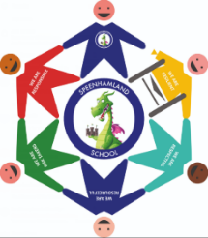We are respectful
* We are responsible
* We are resilient
* We are risk takers
* We are resourceful

If a more serious action occurs with behavior, this may result in a fixed-term exclusion.

Exclusions may be given for:

* Defiance of a senior member of staff
* Physical aggression to any member of the school community
* Bullying including, physical, cyber, racist remarks and sexual harassment

**School Uniform, Equipment and Other Information**

### **School Uniform**

We expect all our pupils to wear the correct school uniform as it is an important part of our school identity. We would like to foster a feeling of community and identity within our school. It helps our pupils feel part of a team and take pride in their appearance too. Our uniform is available to buy through the Skoolkit shop in Newbury. The shop is located in Newbury Town Centre in the Kennet Centre:

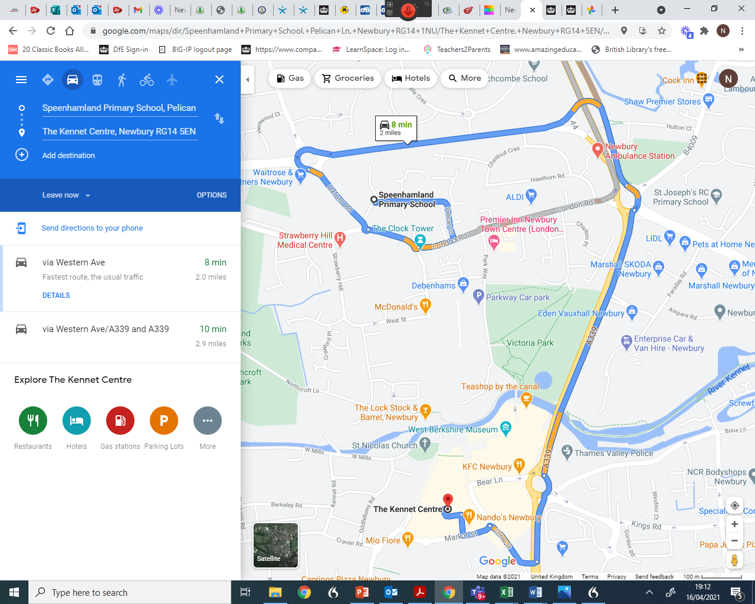

Clothes can also be ordered from the Skoolkit website:

<http://www.trutexuniformsnewbury.co.uk/>

Our school page can be found at:

<https://www.skoolkit.co.uk/school-uniform/1198>

**It is important that all school uniform items are clearly labelled with your child's name.**

**Boys Uniform:**

* Navy polo shirt
* Navy blue sweatshirt with Speenhamland logo
* Grey tailored trousers/shorts
* White, grey or black socks
* Appropriate black school shoes (not trainers)

**Girls Uniform:**

* Navy polo shirt
* Navy blue sweatshirt or cardigan with Speenhamland logo
* Grey skirt/pinafore/trousers/shorts
* Navy blue gingham dress (summer term only)
* Grey or navy tights
* White, grey or black socks
* Appropriate flat black school shoes (not boots or trainers)
* Plain hairbands in school colours

**PE Kit:**

* Speenhamland PE navy t-shirt with logo (long or short sleeves)
* Navy shorts
* Navy skorts (Girls only - optional)
* Navy jogging bottoms (winter term only - optional)
* Plimsolls or trainers

**Other Items:**

* Coats, shower proof jackets, fleece jackets (any colour)
* School book bag (also sold at Skoolkit) or backpack
* Navy PE/swim bag with logo

**NOT Permitted:**

* Jewellery, except a watch and/or a single plain stud earring in either or both ears. If ears are pierced, pupils are responsible for these at all times and earrings are to be removed for PE (and swimming)
* No makeup or nail varnish
* No extremes of hairstyle will be accepted including extremely short cuts or any patterns cut into the hair and unnatural hair colours
* No temporary tattoos

**Notes:**

* Your child’s PE kit must be labelled, kept in the school PE bag and at school every day.
* High Street fashion changes rapidly and consequently the uniform policy can't cater for every possibility. Therefore, the school reserves the right to decide what is and what is not allowed.

## **Equipment**

## We provide all the equipment your child will need for learning, including pens, pencils and books. In Key Stage 2, the pupils sometimes like to bring their own pencil case with equipment into school. This is encouraged again to prepare for the transition to Secondary School but we ask they bring in equipment appropriate for school and learning.

## **Electronic Devices**

There is no need for children to bring mobile phones to school. Where a pupil walks themselves to and from school (Year 6) and there is a need for them to bring a mobile phone for safety reasons, this should be handed to the school office and collected at the end of the day. Please note that mobiles are brought in at your own risk.

**School Meals**

Our school lunches are provided by Aspens. They work with the school to ensure pupils are offered a diverse range of healthy food. Our lunch menus change each week on a 3-week rotation, and the price of a lunch is £2.35 and should be paid daily or in advance through ParentPay. Once your child has started at Speenhamland, you will be provided with a ParentPay letter with login details and instructions. Your child chooses their lunches with you at home via the ParentPay App in advance by 8.00 am each day. Menus can be found on our school website via the following link:

<https://www.speenhamlandprimary.co.uk/page/?title=School+Meals&pid=35>

**Free School Meals**

All children up to the end of Year 2 are entitled to Free School Meals under the Government’s Universal Free School Meal Initiative.

Any family in receipt of specific benefits are encouraged to apply for Free School Meals in addition to this as it means that the school receive additional funding to support the learning of these children.  You can apply for Free School Meals through West Berkshire Council, click on the link below to apply on line or call 01635 503622. This site also gives instructions on how to apply.

<https://www.westberks.gov.uk/article/36469/Apply-for-Free-School-Meals>

## **Special Dietary Requirements**

Some children may have specific dietary needs (e.g. for medical or religious reasons). If this is the case, please let us know by contacting the school office.

## **ParentPay**

We operate a cashless school and use ParentPay to allow parents to pay for school dinners and visits or visitors. Each parent receives log in details to enable them to access their child’s payment account via a letter once admitted.

## **Extracurricular Activities**

As a school, we believe strongly in providing a range of exciting extra-curricular opportunities for our pupils. Each term, we offer a range of after-school clubs which children can sign up for and attend. In addition, we run sports clubs which provide additional practice time for our successful sports teams prior to school fixtures.

**Medical**

Within the school, we have a number of staff who are First Aid trained. If your child requires minor treatment for an injury, we will always treat them on site and record the details centrally. If your child sustains a head injury, we will always notify you by phone or text. If your child becomes ill during the day, we will contact you to come and collect them. If your child needs to take medication during the day, we will ask you to complete a medical form detailing the amount they need to take and how often. It is essential therefore that we always hold the most up-to-date contact details for you. If during the school year any details change, please notify us immediately.

**School to Home Communication**

Every week we send out an electronic newsletter that keeps parents up to date with what is happening in school as well as celebrating our successes. We also use email and texts to communicate. Our website is a key tool in ensuring we keep parents informed and we also use Twitter to share our good news:

<https://www.speenhamlandprimary.co.uk/>

Twitter@SpeenhamlandSch

Each year, there are opportunities to meet your child’s class teacher at Parents Evenings (October and February) where you are invited in to talk about your child’s progress and look at the work they have been doing.

In the Summer Term, every child receives an end of year report which summarises attainment and progress and sets targets for your child to ensure they keep improving.

You can also contact the office for more general enquiries:

[office@speenhamland.newburyacademytrust.org](mailto:office@speenhamland.newburyacademytrust.org)

